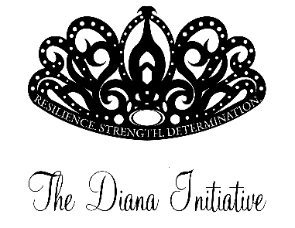
2019 Diana Initiative Speaker Agreement

Return signed agreement by August 1, 2019

The following agreement confirms the terms and conditions of the working relationship between The Diana Initiative and _________________________________. The terms of this agreement shall be from the date the agreement is signed until the agreement is completed or until replaced in full or in part by a modified agreement.

- The Speaker agrees to speak at the scheduled time. If the Speaker is unable to fulfill this obligation they will let The Diana Initiative know as soon as possible.

- The Diana Initiative will not pay an honorarium, or other fees for this presentation/training/workshop.

- Does the Speaker agree to have their photograph taken by The Diana Initiative Staff for use in future promotional materials, website, or social media postings: YES NO

- The Diana Initiative reserves the right to cancel presentations or workshops at any time.

- Every Speaker represents The Diana Initiative while delivering a workshop and is expected to adhere to our Code of Conduct and Inclusion Policies as they are currently published, and are expected to conduct and present themselves in a professional manner while at the event.

____________________________________
Speaker Signature Date
___________________________________________
Email address

__________________________________________
Telephone Number (Work or cell)

_____________________________________________________________________________________
Coordinator’s name Date

